25.63: a) 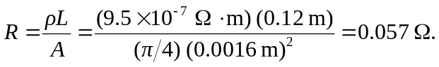
b)

c)
The volume of the fluid remains constant. As the fluid expands the container, outward expansion “becomes” upward expansion due to surface effects.
d) 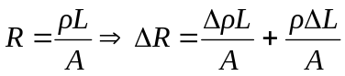
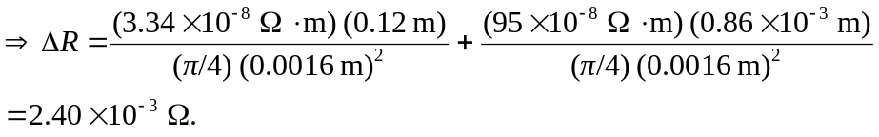
e) From Equation (25.12), 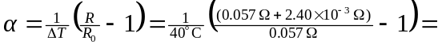
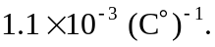 This value is greater than the temperature coefficient of resistivity and therefore is an important change caused by the length increase.

